International Business & Leadership
(One Month Modular Course)

This 4 week intensive course is running from 6th July until 31st July 2015.

Options of Study
- International Business and Leadership Modular course (40 study hours: 2 hours of classes per day)

Fees: £715

Combined study: International Business and Leadership Modular course & General English course

(40 study hours of Business and Leadership modules plus 60 study hours of English: 5 hours of classes per day)

Fees: £1,250

Registration fee: £90

International Business and Leadership Modular course – description and weekly content

WEEK 1 - AWARENESS

Introduction to the course: challenges of International Business and Leadership

The introductory week will consider contemporary challenges of International Business and Leadership in today’s dynamic business world in both the public and private sectors; it will consider international leadership issues and the implications for leaders of issues such as cultural diversity, ethicality, governance and corporate social responsibility (CSR), international politics, the risks and negotiation, and the influence of culture on international Management and Leadership. This is designed to promote self-knowledge and awareness; participants will complete and evaluate themselves across a range of reliable and valid indicators of typical behaviour and maximum performance. The resulting profiles will be discussed within a framework to assist participant’s understanding of self and others, so as to facilitate understanding of people, leadership in multinational enterprise, international trade and financial markets, and people’s expectations of leaders.

WEEK 2 - CHALLENGES

Challenges of International Free Trade and Leadership - leadership theories, the future and prevoyance

The modern challenges facing leaders today will be discussed within a pragmatic and historical context of Leadership Theory. The issue of leadership style, personality, cognition and decision making will be examined within the present day perceived need for intuitive prevoyance against the currently more out of favour evidenced based decision making approach to leading with respect to the markets in The European Union, Japan and North America, Latin America and other emerging economies. This dichotomy and current thinking will be considered. The issue of developing a learning organisation with an appropriate learning culture and climate as a defence to cope with required change and maintain efficiency and effectiveness in an environment which is constantly changing, and to thus enable meaningful organisational coping and response to on-going changes in the external environment, will also be examined.

WEEK 3 - PEOPLE & MARKETS

Powerful Teams: Diversity and high performance - Environmental issues in International Trade

The issues of leading by promoting diversity of people, in all its forms, will be considered along with the link to teams, teamwork and team performance. The legal aspects, as well as the practical and pragmatic aspects, of ethics and environmental issues, international trade, financial markets in various global scenarios will be discussed, along with a focus on diversity in teams and team performance. The characteristics of high performing teams will be considered along with team size and issues linked to competence (doing) and competency (having). The importance of selection and recruitment of employees will also be looked into, alongside an examination of the people management and leadership issues of engagement and empowerment of employees, and the linked issue of trust. Significant research findings will be analysed which indicate that these issues will continue to impact on organisational development initiatives as managers and leaders play ‘catch up’ with on-going research reinforcing these drivers as all important to leadership success. The more controversial aspects of ‘servant’ leadership will be considered and discussed within the engagement/empowerment framework, combined with the study of ‘power’ related issues, ethicality and corporate social responsibility (CSR).

WEEK 4 - STRATEGY

Networks, partnerships and knowledge issues: strategic management and managing change

A series of presentations and discussions on community based issues will be considered within the conceptual and practical areas of networks and networking, political skills development, developing partnerships for mutual benefits and synergy, along with the leadership demands of knowledge management and intellectual property (IP) security. A classic leadership theory and an additional model will be looked at in a strategic context which is useful to help to maintain focus and effort in these complex areas where conjectural competence is essential.
The leadership issues of being a change agent and managing organisational change will be examined within the theoretical context of transformational leadership and within a plethora of change management models and offerings. More classical and historic change management models will re-considered for applicability in today’s fast paced organisational environments.

A plenary session will consider the International Business and Leadership course. Participants will contribute their opinions and views of specific aspects and elements of the course identified as beneficial and those to be considered for further reflection and consideration.
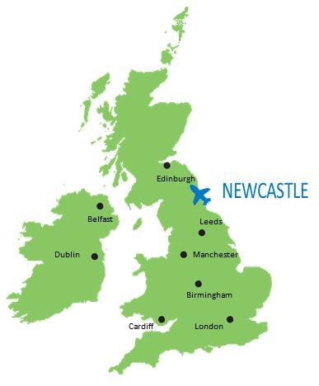

Requirement: Minimum Level of English Language - Intermediate

Deadline for applications: 29th May 2015

Studying with a small group of people provided an atmosphere of trust, exchange of ideas, improvised discussions and the opportunity to establish valuable friendships. Andrea Urquizo, Ecuador, Student in 2013-2014
“

For more information, please contact: International Officer - Clarisse Almeida
Email: clarisse.almeida@ncl-coll.ac.uk
SKYPE: clarissealmeidanewcastlecollege

